LCBCAdminSystem Setup Manual.

by Alpha Solutions Inc.


Table of Contents

Getting Started……………………………………………..……..…………………….2
System Requirements……………………………..……………………..………2
Executing the installation program………………..…..………………………………3
The .NET 2.0 Runtime installer………………..……………..………………….3
Choosing a Directory…………………………………………………………….5

Getting Started

This document contains information on how to complete the installation of the Lower Caribbean Bible College Administrative System. This manual contains documentation for users of all levels, from beginners to advanced users. Before you begin installation you should consider the following requirements:

System Requirements

- A Pentium-compatible PC
- 300 MHz CPU
- Microsoft Windows 98, NT, 2000 or XP
- .NET 2.0 runtime (included with installer) and Administrative privileges on the PC
- 64 MB RAM minimum
- 60 MB free hard disk space

Executing the installation program.

Double click the setup.exe icon to begin the installation process.

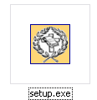

The .NET 2.0 Runtime installer.

The LCBCAdminSystem requires the .net 2.0 framework to operate. Many end users do not have this runtime installed so it is bundled in the installer. After executing the setup program if you do not have the .NET runtime installed yu will be prompted to install it with the following message box:

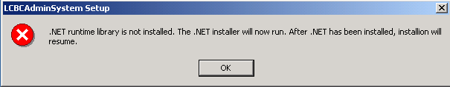

After you click ok you will then proceeded to install the .NET 2.0 runtime. You should have Administrative rights on the computer that you are using if not the .NET runtime setup will fail. The following is a screenshot of the .NET 2.0 runtime installer.

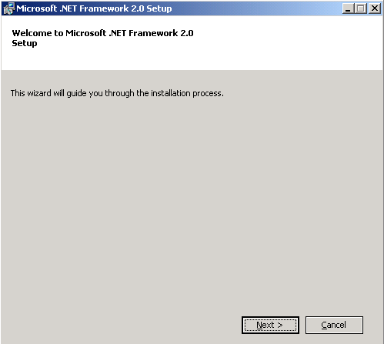

Click on the Next button and follow the steps.

You should be greeted with the following page if the .NET runtime is installed on your system.

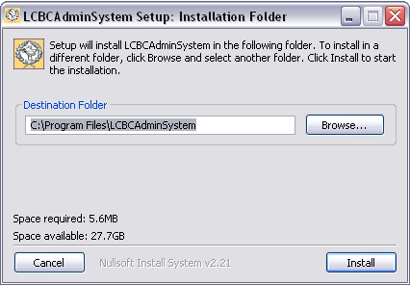

Click the install button to begin installation.

Choosing a Directory

The default directory is “program files” and it is recommended that you do not change it but if you decide to you will be presented with the following dialog:

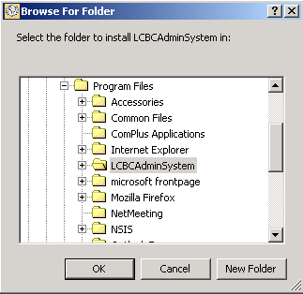

Using the above dialog, browse to the preferred directory to select the installation location.

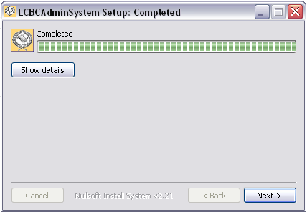

After copying the files to the installation directory setup will be complete.

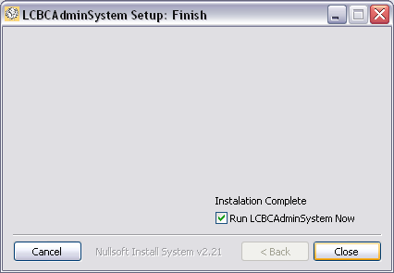

By default when you close the installation program you will be allowed to run LCBCAdminSystem as seen next.

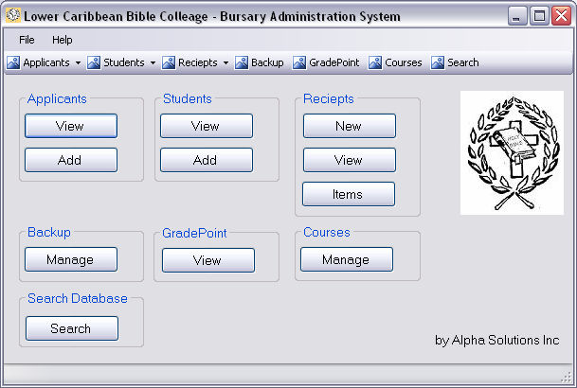

© Alpha Solutions Inc.

